Chapter 1 - What is Strategy and Why is it Important? (Lecture 1)

LO 1-1 Understand what is meant by a company’s strategy and why it needs to differ from competitors’ strategies.

A company’s strategy is the set of coordinated actions that its managers take in order to outperform the company’s competitors and achieve superior profitability. (should identify what a firm should and should not do)
- How to position the company in the marketplace. (Market Positioning)
- How to attract customers. (Customer Acquisition)
- How to compete against rivals.
- How to achieve the company’s performance targets.
- How to capitalize on opportunities to grow the business.
- How to respond to changing economic and market conditions. (PESTEL)

It is not enough to copy successful strategies of competitors. Every company needs to have a distinctive element that enables them to differentiate itself from competitors(doing what rivals can’t or don’t do). Businesses must aim to (1) appeal to buyers by offering a value proposition greater than competitors and (2) position themselves in a market that is not crowded with strong competitors.

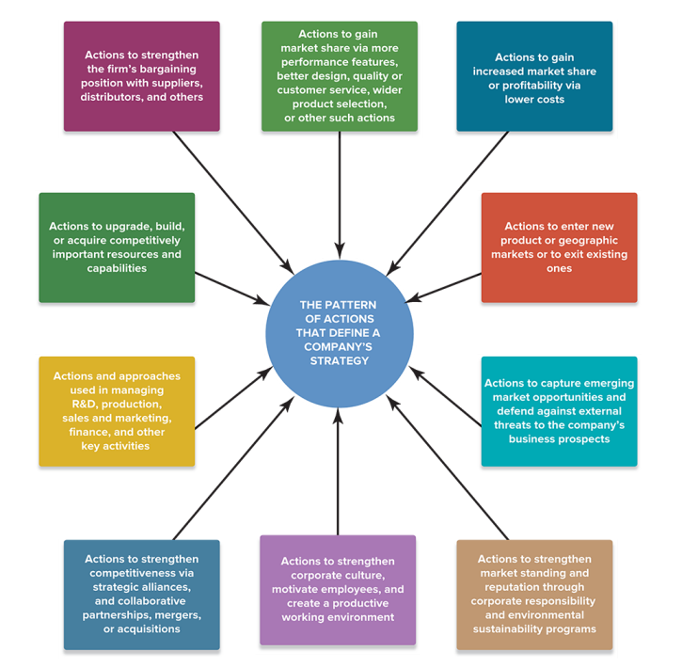
LO 1-2 Grasp the concept of a sustainable competitive advantage.
A company achieves a competitive advantage when it provides buyers with superior value compared to rival sellers or offers the same value at a lower cost to the firm. The advantage is sustainable if it persists despite the best efforts of competitors to match or surpass this advantage.

LO 1-3 Identify the five most basic strategic approaches for setting a company apart from its rivals.

- Low-cost provider - achieve a cost based advantage over rivals. (Walmart)
- Broad Differentiation - differentiate p&s from rivals in ways that appeal to a broad range of buyers(Apple).
  - To increase strategy sustainability, continuous innovation is required to prevent threats of imitation.
- Focused low-cost - target a niche market(narrow buyer segment) and out-compete customers through lower costs. (IKEA)
- Focused Differentiation - target a niche market and outcompeting rivals by offering customized attributes that meet the specialized needs of buyers more so than rival’s. (Lululemon, LinkedIn)
- Best-Cost Provider - dual focus on low cost and highly differentiated. (Target)

2 Core Value Proposition | Low Cost | Focused Low Cost | Low Cost Provider | Best-Cost Provider
2 Core Value Proposition | Differentiation | Focused Differentiation | Broad Differentiation | Best-Cost Provider
 |  | Niche | Broad
 |  | Target Market Segmentation

Experience, know-how, and specialized capabilities that a company has developed and perfected over a long period of time is substantially harder to do and takes much longer for rivals to copy.

Cost drivers
- Economy of Scale
- Learning and Experience
- Capacity Utilization
- Supply Chain Efficiencies
- Input costs - can address through increasing bargaining power over suppliers
- Production technology and design - industrial transformation through design for manufacture(DFM) procedures, robotics, etc
- Communication systems and IT - using online systems and sophisticated software to achieve operating efficiencies. DIGITAL TRANSFORMATION YEEAHHHH
- Bargaining Power to suppliers and customers.
- Outsourcing or vertical integration
- Incentive Systems and Culture - culture is a critical competitive advantage(hard to copy).

Value Drivers
- Product features and performance that appeals to specific or wide range of buyers
- Customer service (improve or add)
- Product R&D (invest to enhance)
- Technology and innovation
- Adopt continuous quality improvement processes
- Input quality - better cuts of diamonds, better ingredients
- Employee skill, training, experience
- Sales and marketing, distribution
- Quality control process
- Improve human resource capabilities: train to improve skills and expertise to build organizational competencies.

LO 1-4 Understand why a company’s strategy tends to evolve.

Changing circumstances(external) and ongoing management efforts(internal)to improve the strategy causing a company’s strategy to evolve over time —a condition that makes the task of crafting strategy a work in progress, not a one-time event.

A sustainable strategy is an evolving strategy. Companies must strive to reinvent their approach to providing value when facing disruptions. The speed it evolves depends on the degree of change.

For changing circumstances, consider PESTAL and Porter’s Five Forces. Common triggers for an emergency shift in strategy includes: dramatic change in industry(invention of 3D printing, shale fracking).

A company’s strategy is shaped partly by management analysis and choice and partly by the necessity of adapting and learning by doing.
- Deliberate strategy(Proactive) - internal initiatives to improve performance and secure long lasting competitive advantage.
- Emergent Strategy(Reactive) - responses to unanticipated external developments(consider how businesses may plan for uncertainties and risks, a topic covered in Skills and Values). A good strategy is not about eliminating risks, but increasing the odds of success). Ability to identify changing conditions and adapting is a core attribute of a successful entrepreneur.

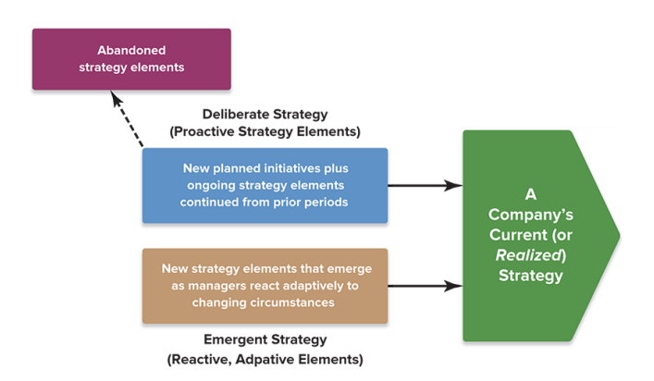
It is important to note that a strategy cannot be considered ethical just because it involves actions that are legal. To meet the standard of being ethical, a strategy must entail actions and behavior that can pass moral scrutiny in the sense of not being deceitful, unfair or harmful to others, disreputable, or unreasonably damaging to the environment.
- Management must constantly contextualize their strategic actions in the field of ethics, as reputational and financial damage from unethical behavior can be substantial(Enron).

LO 1-5 Identify what constitutes a viable business model.

A company’s business model sets forth the logic for how its strategy will create value for customers and at the same time generate revenues sufficient to cover costs and realize a profit.
- A business model has two parts: value proposition(Value and Price) and profit formula (Price and Cost)
- 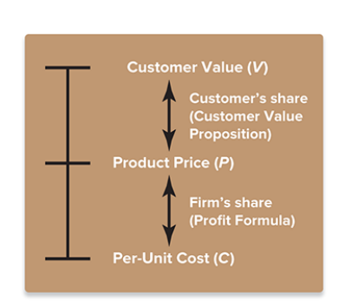

LO 1-6 Identify the three tests of a winning strategy.

- The Fit Test: How well does the strategy fit the company’s situation? To pass the fitness test, the strategy must be aligned in three dimensions:
  - External fit - synergy with market conditions
  - Internal fit - synergy with the company's current resource limitation(Man, Money, etc)
  - Dynamic Fit - able to evolve over time to maintain close alignment with external and internal conditions.
- Competitive Advantage Test: Is the strategy helping the company achieve a competitive advantage? Is the competitive advantage likely to be sustainable? The competitive advantage must be (1) superior to that of rivals as well as (2)sustainable.
- Performance Test: Is the strategy producing superior company performance? Must be judged on two criteria:
  - Competitive strength and market standing - gains in market share, competitive position
  - Profitability and financial strength - above average financial performance

To ensure success, management must scrutinize each possible strategy closely to ensure that resources are not wasted in its pursuit.

Good strategy + Good Execution = Good Management.
- How well a company performs is directly attributable to the caliber of its strategy and the proficiency with which the strategy is executed.

Chapter 2 - Charting a Company’s Direction (Lecture 2)

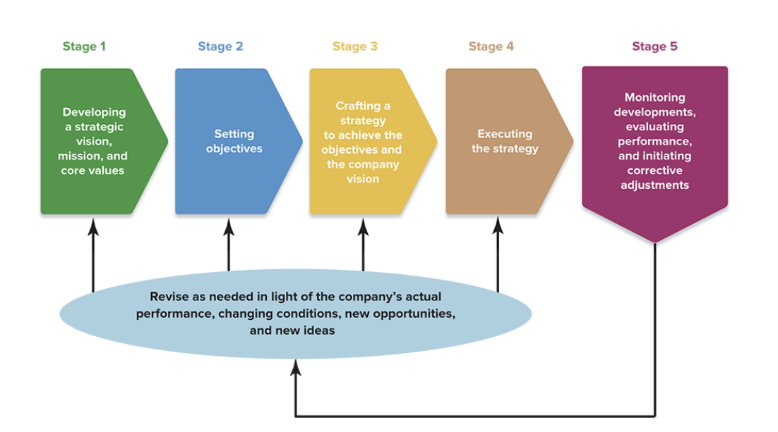
Steps to the strategy making and executing process
- Developing a strategic vision, mission statements and core values
- Setting objectives to convert vision and mission into performance targets.
- Crafting a strategy to achieve the objectives in pursuit of vision and mission.
- Executing the chosen strategy. Easily the most demanding and time-consuming part of the strategic management process. The degree of internal change correlates to the length of time required for implementation.
- Continuous improvements(monitor, evaluate, corrective adjustments). Is trigger point for deciding whether to continue or change the company’s vision and mission, objectives, strategy, business model and/or strategy execution methods.

LO 2-1 Understand why it is critical for managers to have a clear strategic vision of where the company needs to head.

A strategic vision describes management’s aspirations for the company’s future and the course and direction charted to achieve them. It is focused on the future. A good vision is (1)distinctive and (2)specific and should not be vague, should mention ‘where we are going, and why.

Benefits of a clear strategic vision
- Makes it clear to senior executives (consider in-group concept, cognitive alignment, path goal theory)
- Reduce risk of conflicting decision making
- Ensure support of organizational members > make vision a reality
- Useful when crafting departmental objectives (make sure they align with vision, easier when it is clear)
- Good way to prepare for the future.

A company’s mission statement describes the scope and purpose of its present business(who we are, what we do, and why we are here). It is focused on the present. A good mission statement should identify (1)the firm’s P&S, and (2)specific target customer group, as well as (3)give the firm an identity.
- Financial success should not be a company’s mission, as it is more so an objective and a result of a company’s mission.

A company’s core value describes the beliefs, traits, and behavioral norms that company personnel are expected to display in conducting the company’s business and pursuing its strategic vision and mission. Such values can ensure successful pursuit of a company’s vision and mission if it can be realistically practiced. To ensure this, management must create a company culture that encourages such values.

LO 2-2 Explain the importance of setting both strategic and financial objectives.

Objectives are an organization’s performance targets —the specific results management wants to achieve(pursuit of vision). A good objective is specific, measurable, time limited, challenging, achievable.
- Stretch objectives - set performance targets high enough to stretch an organization to perform at its full potential and deliver the best possible results. Extreme stretch goals are warranted only under certain conditions.
- Financial Objectives - communicate management’s goals for financial performance(increase profitability by x percent, improve credit rating by x percent, etc).
  - Financial performance measures are lagging indicators, it takes time for strategic success to be reflected in a company’s balance sheet and P&L.
- Strategic Objectives - lay out target outcomes concerning a company’s market standing, competitive position, and future business prospects(gain x% market share, lower cost than rivals, etc).
  - Strategic outcomes are leading indicators, and is a more direct measure of strategic accomplishment.

Objectives should also be time limited. Short term objectives focus attention on quarterly and annual performance improvements to satisfy near-term shareholder expectations. Long term objectives force consideration of what to do now to achieve optimal long term performance. Help pose a barrier to overemphasize achieving just short term results and postponing delaying actions needed to achieve long term performance targets.
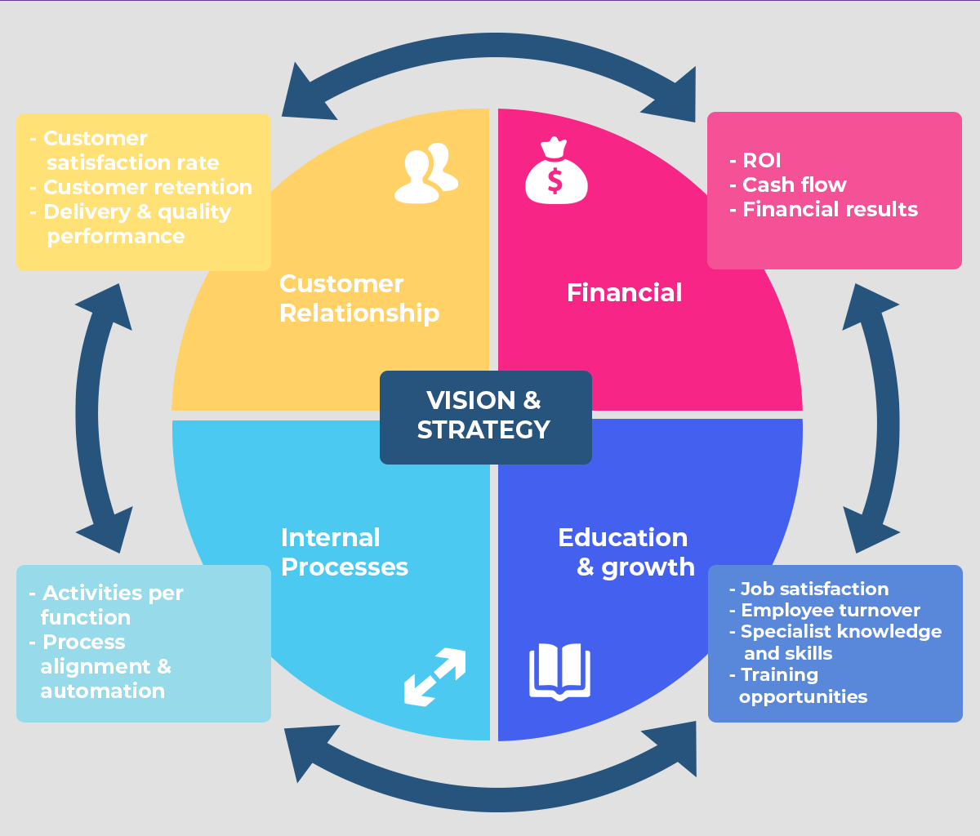

It is important to link financial and strategic objectives together. A balanced scorecard can achieve this as it gives management a more complete and balanced view of how well an organization is performing(consider what we learned in entrepreneurial management). The four dimensions of a balanced scorecard includes
- Financial - list of financial objectives.
- Customer - relating to customers & market
- Internal process - relating to productivity & quality.
- Organizational - human resources, culture, etc.

Objectives must be broken down into performance targets for each specific work unit. Objective setting is a top-down process.

LO 2-3 Explain why the strategic initiatives taken at various organizational levels must be tightly coordinated.

A company’s strategy is at full power only when its many pieces are united. Anything less than a unified collection of strategies weakens the overall strategy and is likely to impair company performance.

A company’s strategic plan lays out its direction, business model, competitive strategy, and performance targets for some specified period of time. Strategic Plan = Strategic vision + mission + objectives + strategy

Crafting and executing strategy should be a collaborative team effort in which every manager has a role for the area he or she heads; as each individual provides contextualized insights. It should not be finalized by a small group of top management(consider fair process leadership). While it is a top down initiative, communication between management hierarchy(process of accurate translation of corporate strategy into business strategy) is critical to ensure success.

- Corporate strategy establishes an overall game plan for managing a set of businesses in a diversified, multibusiness company.
- Business strategy is primarily concerned with strengthening the company’s market position and building competitive advantage in a single-business company or in a single business unit of a diversified multibusiness corporation.
- Operating Strategy concerns the relatively narrow approaches for managing key operating units (e.g., plants, distribution centers, purchasing centers) and specific operating activities with strategic significance (e.g., quality control, materials purchasing, brand management, Internet sales).
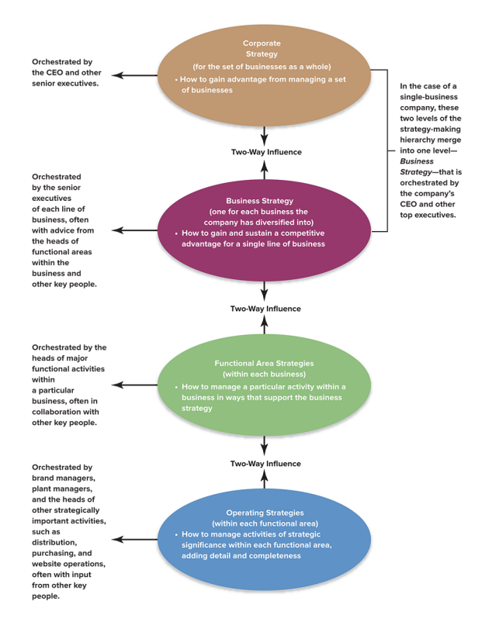

LO 2-4 Recognize what a company must do to execute its strategy proficiently.

Good Management
- Creating a strategy supporting structure
- Ensure sufficient human resource capability (obtaining headcount, effective recruitment and training)
- Ensure sufficient financial resource for execution (budgeting)
- Clear policies and procedures

Good Leadership
- Mentorship and coaching to build productive work culture
- Motivate company personnel
- Ability to direct organizational change to strengthen competitive capabilities

LO 2-5 Comprehend the role and responsibility of a company’s board of directors in overseeing the strategic management process.

Effective corporate governance demands four important obligations:
- Ensure that the company issues accurate financial reports and has adequate financial controls
- Critically appraise the company’s direction, strategy, and strategy execution
- Evaluate the caliber of senior executives’ strategic leadership skills
- Institute a compensation plan for top executives that rewards them for actions and results that serve stakeholder interests, most especially those of shareholders.

A strong independent board of directors is proactive.
- Well informed about the company’s performance
- Guides and guides the CEO and other top executives
- Has the courage to curb inappropriate or risky actions made by management.
- Certifies to shareholders that the CEO is doing what the board expects (takes accountability)
- Provide insight and advice to management (expert power)
- Involved in debating pros and cons of key strategic decisions and actions.

Chapter 9 - Ethics, Corporate Social Responsibility, Environmental Sustainability, and Strategy (Lecture 3) TDLR: because it is the right thing to do, and if done well can maximize the company's value.

Every action a company takes can be interpreted as a statement of what it stands for.

LO 9-1 Understand why the standards of ethical behavior in business are no different from ethical standards in general.

Business actions have to be judged in the context of society’s standards of right and wrong, not with respect to a special set of ethical standards applicable only to business situations.

Business ethics deals with the application of general ethical principles to the actions and decisions of businesses and the conduct of their personnel. Two conflicting schools of thought exist when considering a business’s code of conduct.

- The school of ethical universalism holds that the most fundamental conceptions of right and wrong are universal and apply to members of all societies, all companies, and all businesspeople. Examples: lying is bad, hurting others is bad, therefore claiming that a product does X while it does not is bad, and not providing safety equipment for workers is bad.

- The school of ethical relativism holds that differing religious beliefs, customs, and behavioral norms across countries and cultures give rise to differing standards concerning what is ethically right or wrong. These differing standards mean that whether business-related actions are right or wrong depends on the prevailing local ethical standards. Under ethical relativism, there can be no one-size-fits all set of authentic ethical norms against which to gauge the conduct of company personnel. Consider these issues:
  - Child labor - in some countries, sending children to school is not a realistic option as the family does not have enough money to eat.
  - Bribery - in some countries, it is impossible to do business without using bribery.
  - Codes of conduct based on ethical relativism can be ethically problematic for multinational companies by creating a maze of conflicting ethical standards, double standards across borders.. It is not recommended.
- Between these two schools of thoughts, a theory exists that serves as a middle ground. According to integrated social contracts theory, universal ethical principles based on the collective views of multiple societies form a “social contract” that all individuals and organizations have a duty to observe in all situations. Within the boundaries of this social contract, local cultures or groups can specify what additional actions may or may not be ethically permissible.
  - Moral free space - local ethical standards should only be more ethical than universal ethical norms to be considered.
  - Accommodates the best parts of ethical universalism and ethical relativism.

LO 9-2 Recognize conditions that give rise to unethical business strategies and behavior.

- Faulty oversight - blinded while pursuing personal gain and self interest
- Heavy pressures to reach short-term performance targets ‘do whatever it takes’
  - Short-termism is the tendency for managers to focus excessively on short-term performance objectives at the expense of longer term strategic objectives. It has negative implications for the likelihood of ethical lapses as well as company performance in the longer run.
- Company culture that puts profitability and business performance ahead of ethical behavior

Self-dealing occurs when managers take advantage of their position to further their own private interests rather than those of the firm. The board must oversee management closely to mitigate risk.

LO 9-3 Identify the costs of business ethics failures.
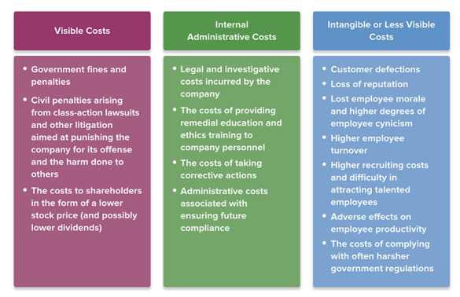
Shareholders suffer major damage when a company’s unethical behavior is discovered. Making amends for unethical business conduct is costly, and it takes years to rehabilitate a tarnished company reputation.

LO 9-4 Understand the concepts of corporate social responsibility and environmental sustainability and how companies balance these duties with economic responsibilities to shareholders

Corporate social responsibility (CSR) refers to a company’s duty to operate in an honorable manner, provide good working conditions for employees, encourage workforce diversity, be a good steward of the environment, and actively work to better the quality of life in the local communities where it operates and in society at large.

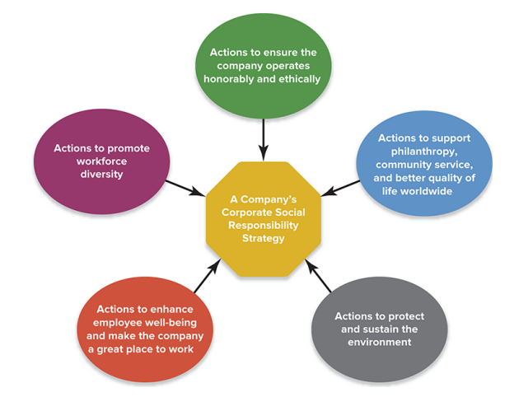
- Commitment to ethical strategy and observation of ethical principles when operating the business.
- Social contributions to stakeholders and the community at large(donation, community service, etc)
- Minimize/eliminate adverse impact on the environment stemming from the company’s business activities(wastewater treatment, sustainably sourced raw materials).
  - Better if it is done above and beyond what is required by law.
- Create work environment that enhances the employee’s quality of life (consider work-life blend, a topic we learned in our leadership class)
- Recruit and employ a diverse workforce. Celebration of diversity. Accommodate those with disabilities.

A company’s CSR strategy is defined by the specific combination of socially beneficial activities the company opts to support with its contributions of time, money, and other resources. Related terminology: corporate citizenship, corporate responsibility, sustainable responsible business(SRB).
- Sustainable business practices are those that meet the needs of the present without compromising the ability to meet the needs of the future(we learned this definition in S&V).

Corporate social responsibility improves the company’s triple bottom line (TBL). “three pillars of people, planet, profit”. Businesses should strive to improve all three dimensions.
- Economic - performance metric for not only profitability of the firm, but also the economic impact that the company has on society- the value that it creates and the overall costs that it imposes on society.
- Social - performance metric for care of stakeholders, corporate giving, community involvement, and company efforts to improve the lives of its internal and external stakeholders.
- Environmental - performance metric for care of environment
  - A company’s environmental sustainability strategy consists of its deliberate actions to protect the environment, provide for the longevity of natural resources, maintain ecological support systems for future generations, and guard against ultimate endangerment of the planet.

Integrating CSR in ways that boost the firm’s value proposition is key to ensuring a sustainable competitive advantage.
- link company valuable resources and capabilities, as well as value chain activities to CSR initiatives
- CSR strategies and environmental sustainability strategies that both provide valuable social benefits and fulfill customer needs in a superior fashion can lead to competitive advantage. Corporate social agendas that address only social issues may help boost a company’s reputation for corporate citizenship but are unlikely to improve its competitive strength in the marketplace.

Benefits of CSR on Firm’s Performance = boost VP as well as shareholder value
- Secure sustainable competitive advantage
- Create value for customers, CSR increases buyer’s patronage - appeal to customers’s care for the world
- Reduce risk of reputation damaging incidents - The higher the public profile of a company or its brand, the greater the scrutiny of its activities and the higher the potential for it to become a target for pressure group action.
- Boost employee retention rate, lowers cost

Chapter 3 - Evaluating a Company’s External Environment (Lecture 4) - PESTEL, FIVE FORCES, DRIVING FORCES, STRATEGY GROUPS, COMPETITOR ANALYSIS, KEY SUCCESS FACTORS

2 types of Macro-Trends:
- Predetermined elements are relatively stable or predictable, like demographic shifts but the consequences haven’t been planned for adequately enough yet. For these trends, you need to forecast its impact(high/low)
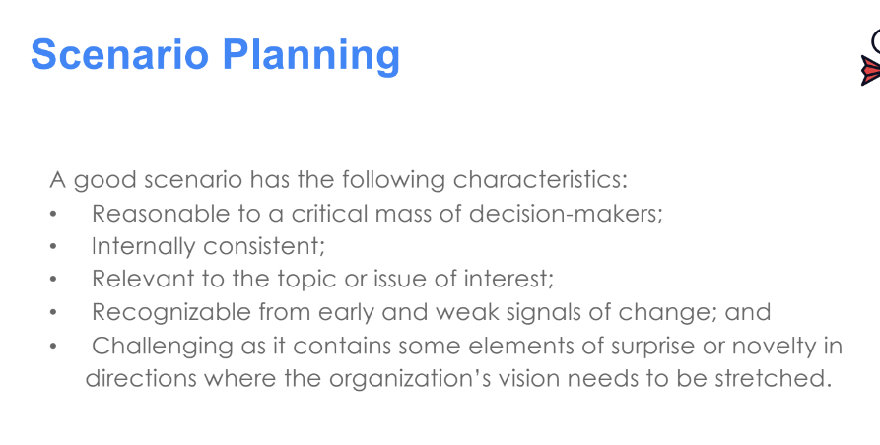
- Critical uncertainties are unstable or unpredictable, such as consumer tastes, government regulations, natural disasters, or new technologies or products. For these trends you need scenario planning
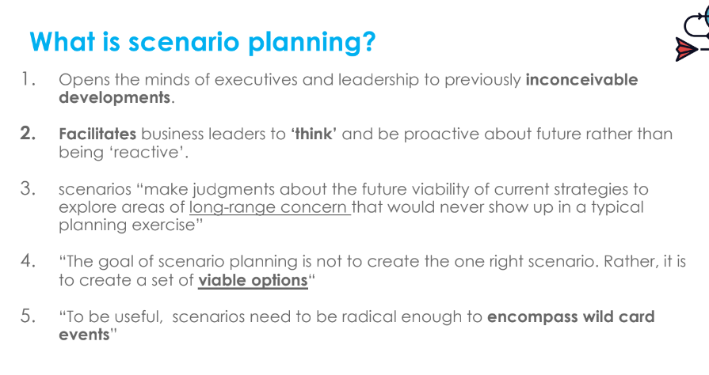

LO 3-1 Recognize the factors in a company’s broad macroenvironment that may have strategic significance.
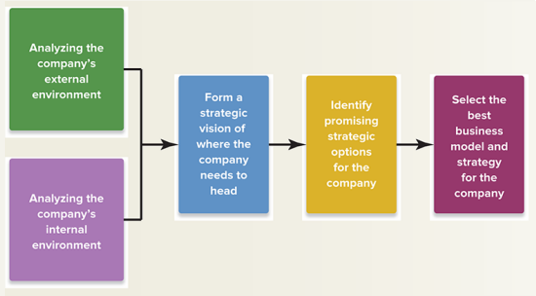

Before forming a strategic vision, the firm must first consider the strategically relevant factors in both the company’s internal and external environment. The external environment can be viewed in Macro and Micro.
- Relevant factors: important enough to impact decision making as it impacts the firm’s
  - LT direction
  - Objectives and Strategies
  - Business Model
- MACROENVIRONMENT - PESTEL ANALYSIS, FACTORS AND ACTORS. - A macro trend is a CLEAR shift in the direction of some phenomenon on a global level & characterized in terms of their longevity. Short term trends are fads.
  - Political - policy changes, bigger picture topics such as tax policy, trade policy, or foreign trade policy
  - Environmental - climate change, government pressures
  - Social - consumer buying trends, employee work standards,
  - Technological - Blockchain, metaverse
  - Economical
  - Legal - more specific than political, relate to topics such as discrimination laws, antitrust laws, or intellectual property laws(Key difference is that political factors are led by government policy, whereas legal factors must be complied with).
  - Consider Knock On Impacts - A factor that leads to a change in another factor.
- MICROENVIRONMENT - PORTER’s FIVE FORCES (learned in S&V)

Consider Black Swan events that cause societal shock such as Covid, wars, etc not covered in PESTEL. A set of irregular and unpredictable events that has a large impact on society.

LO 3-2 Use analytic tools to diagnose the competitive conditions in a company’s industry.

The strongest of the five forces determines the extent of the downward pressure on an industry’s profitability. Through understanding of the competitive conditions, (1)Shield Strategies can be used to mitigate competitive pressure, and (2) actions can be taken to lower the factors that contribute to the pressure.
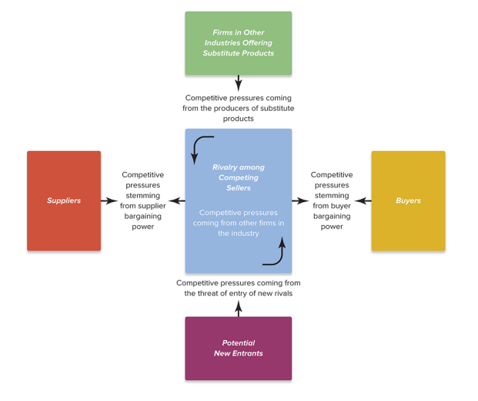
Three Steps:
Identify parties involved
Evaluate the level of impact(strong, medium, weak)
Determine if the industry can be profitable overall given the forces involved.
Defensive Strategies by existing businesses

Threat of entry is strong when entry barriers and threats of retaliation from current players are low.
- Whether Entry Barriers are High or Low
  - Economy of scale required to be competitive
  - patents or IP rights, exclusive partnerships, location
  - High learning curve (technical, RD required)
  - high brand loyalty(what’s EST? I only know coke and pepsi)
  - “Network Effect”, ecosystem value. everyone is using this brand, I will keep using this brand.
  - Capital Requirements ar high - large investment is needed
  - distribution channel limitation, supermarket won’t give us shelf space, they said its full.
  - restrictive regulatory and trade policies - need to be certified and approved by gov to sell, if we sell in China, our products get taxed a lot :(
- The expected reaction of industry members in defending against new entry -
  - New entrants may fear that they can not compete with a larger firm that currently dominates the market
  - New entrants may fear retaliation from current market dominators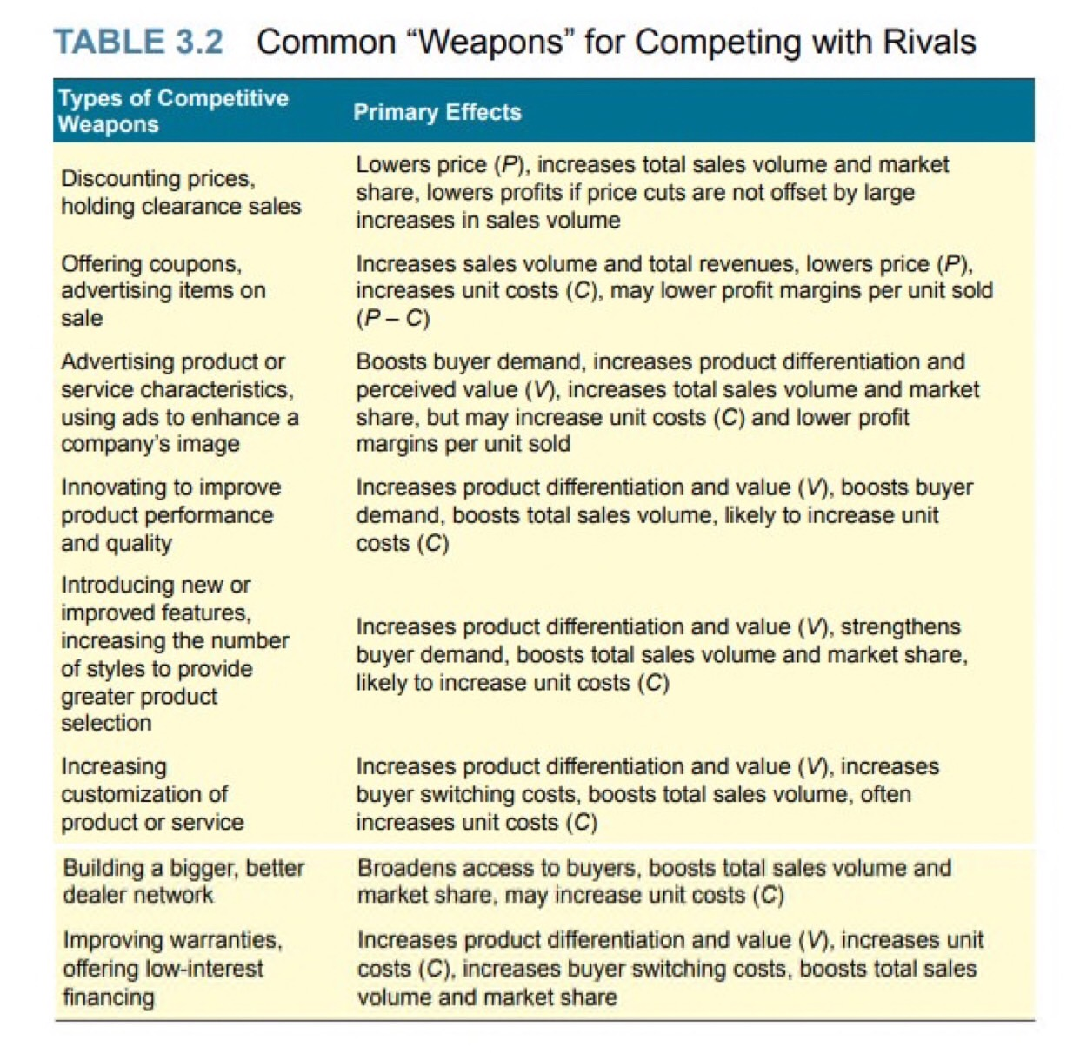
  - Restaurant industries have limited ways to launch defensive strategies, as they can not block a new restaurant from opening up in the same area.
  - The size and reputation of new players helps them bypass high entry barriers. Consider:
    - Honda’s entry into the lawnmower business
    - Samsung’s entry into the smartphone market.

Rivalry among competing sellers increases when:
- Demand for product is low = shrinking market size = aggressive competition strategy by rivals to maintain revenue
- Switching cost is low, not only due to price of the product, but also due to increased accessibility of substitutes.
  - Consider psychological costs of switching
    - Length of doing businesses - customers may hesitate to switch as they have been buying from us for so long and fear severing long term supplier relationships.
    - Emotional attachment - I will only eat kraft cheese because I grew up eating it.
- Surplus of Supply = high holding costs = price reductions = price war
- Quantity and Quality of Competitor increases
  - Low quantity of competitor - “its a small industry, if I am aggressive in the market, they will be aggressive back and I am scared of them”. Fear of competitor’s retaliation leads to restrained competitive movies.
  - As competitors grow to be as big as you are, our competitive strength is equally matched, and an evenly matched contest is usually fiercer.
- Competitor diversity increases = more aspects of differentiation = unpredictability
  - Ex. Alibaba entering the global market. A lot of amazon basics products are manufactured in china. How can amazon sell at a lower price than alibaba? Alibaba wants to go 3 days global shipping while amazon promises 1 day shipping in the US.
- High exit barrier exists = unprofitable firms still can’t leave the business = desperation = high competition

Competitive Pressures from substitutes are strong when they exist, VP is comparable and switching costs are low. Indicators:
- higher substitute sales
- substitute’s production capacity increases
- profits of substitutes are rising

Bargaining power of customers are high when:
- Market demand is low, supply is high
- Products are standardized (pharmaceuticals)
- Switching cost is low
- Buyers are large, small in numbers (ชาวนาขายข้าวให้โรงสีขาวใหญ่ๆ ถ้าไม่ขายให้เค้า ก็ไม่รู้ว่าต้องขายให้ใคร)
- Risk of buyers vertically integrating into the industry
- Buyers have access to price, quality, cost of other competitors(can compare VP easily)
- Buyers can postpone purchases, ask for refunds, and return the product easily.
- Buyers are price sensitive
  - Buyers earn low profit or income(product price is a significant portion of their income)
  - Product quality or level of differentiation is not important (it's all the same, give me the cheapest one, ex. diapers).

Bargaining power of suppliers are high when:
- Supply shortage exists
- High switching costs
- Not a lot of substitute suppliers (small number of suppliers)
- Hard for current players to integrate backwards and do it themselves
- Supplier’s product is a key raw material that makes up the bulk of the firm’s cost
- Suppliers are super big and the firm doesn’t buy a lot(contributes a small amount to supplier’s sales)
  - SCGP has a high bargaining power when selling to small box manufacturers.

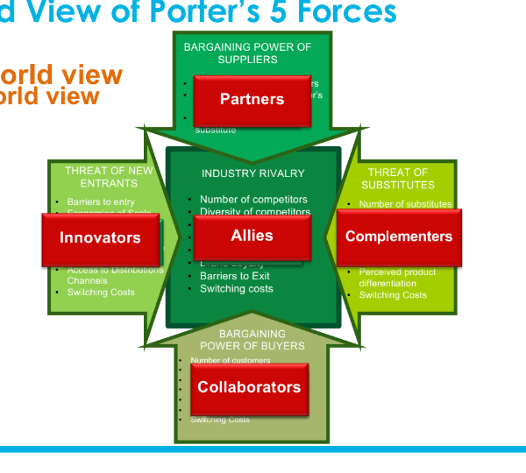
Not all factors affecting the market have to be competitive. You may choose to cooperate with suppliers, customers, competitors, and complementors instead. Complementors are the producers of complementary products, which are products that enhance the value of the focal firm’s products when they are used together.

Driving forces are the major underlying causes of change in industry and competitive conditions. Good managers use driving-forces analysis to help understand what strategy changes are needed to prepare for the impacts of the driving forces.
- Consider its effects on the industry
  - Market size
  - Competitiveness of industry
  - Industry profitability
- Common drivers of industry change
  - Changes in LT industry growth rate
  - Increasing globalization
  - Emerging new Internet capabilities and applications
  - Shifts in buyer demographics
  - Technological change and manufacturing process innovation
  - Product and marketing innovation
  - Entry or exit of major firms
  - Diffusion of technical know-how across companies and countries
  - Changes in cost and efficiency
  - Reductions in uncertainty and business risk
  - Regulatory influences and government policy changes
  - Changing societal concerns, attitudes, and lifestyles

LO 3-3 Map the market positions of key groups of industry rivals.

Strategic group mapping is a technique for displaying the different market or competitive positions that rival firms occupy in the industry.
- Good managers identify ‘white spaces’ within the industry to exploit and capture new demand
- Grouping Variables:
  - Product/Service line breadth
  - Similar PQC
  - Distribution channel
  - Geographic coverage
  - Degree of product/service differentiation
  - Degree of vertical integration
  - Technological approach (non dairy milk can be soy, almond, cashew, oat, etc)
- Guidelines for strategic group mapping:
  - Don’t plot pairs that are correlated (broad product line and broad distribution channel)
  - Variables should reflect different rival approaches
  - Variables can be discrete and not continuous
  - Use circle size to illustrate size of competitors
  - Can make multiple group maps
- Strategic group maps reveal which companies are close competitors and which are distant competitors.
- Not all positions on the map are equally attractive, some positions may not be profitable, industry driving forces may be higher
- A strategic group is a cluster of industry rivals that have similar competitive approaches and market positions.
- Mobility barriers restrict firms in one strategic group from entering another more attractive strategic group in the same industry.

SOAR Framework - Gathering competitive intelligence can help firms prepare defensive countermoves.
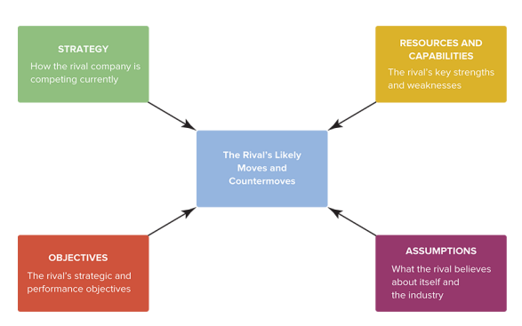
How are they positioned on the market, what is their CompAd? What types of things are they investing in?
Financial and strategic objectives, are they meeting them? Are they in a hurry to improve? If they are performing poorly, they may take dramatic actions out of desperation
What are their constraints? What are they limited by? Country? finance?
How confident are they? Do they think their dicks are so big that no competitors can beat them?

Key success factors are the strategy elements, product and service attributes, operational approaches, resources, and competitive capabilities that are essential to surviving and thriving in the industry. Good managers must identify these factors to create strategic plans to achieve these factors and ensure long term success. Consider:
- What do customers want the most? What is the best value proposition?
- What resources and competitive capabilities must we have?
- What risks exist that if it happens, would put the company at a significant disadvantage?
Examples of Beer industry’s key success factors: strong network of wholesale distributors, clever advertising, superior product differentiation, superior firm size and branding capabilities, full utilization of brewing capacity(EOS).

LO 3-4 Determine whether an industry’s outlook presents a company with sufficiently attractive opportunities for growth and profitability.

The anticipated industry environment is fundamentally attractive if it presents a company with a good opportunity for above-average profitability. Attractiveness is relative as current players and new players are not in the same position.

Chapter 4 - Analysis of the firm’s internal situation: a Company’s Resources, Capabilities, and Competitiveness (Lecture 5)

Internal analysis enables managers to determine whether their strategy is likely to give the company a significant competitive edge over rival firms- given the external conditions learned in Chapter 3. When internal and external analysis are used in combination, it enables the firm to reposition itself to take advantage of new opportunities to cope with emerging competitive threats.

LO 4-1 Evaluate how well a company’s strategy is working.

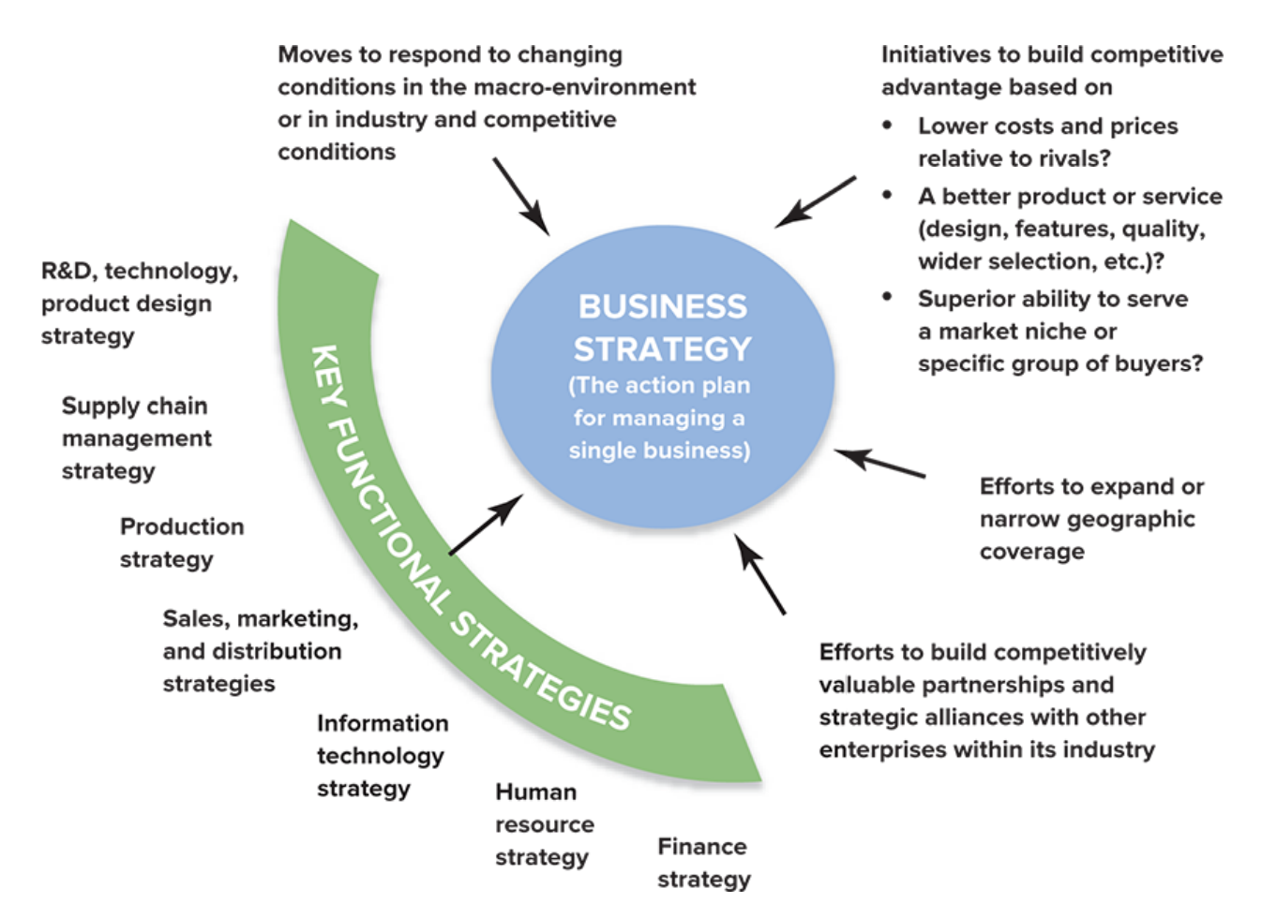

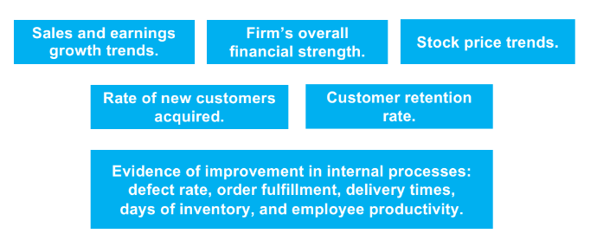
When evaluating the effectiveness of a strategy, two aspects must be considered: achievement of financial and strategic objectives
- Is our financial performance above industry average?
  - Sales and earnings growth
  - Stock price
  - Financial strength
- Are we gaining customers and gaining market share? Is our competitive strength improving?
  - Customer retention rate
  - Rate of new customer acquisition
  - Internal: defect rate, order fulfillment, delivery time, days of inventory, employee productivity

Sluggish financial performance and second-rate market accomplishments almost always signal weak strategy, weak execution, or both.

LO 4-2 Assess the company’s strengths and weaknesses in light of market opportunities and external threats.

SWOT analysis can help a company with a strategy that is working well in the present to determine whether the company is in a position to pursue new market opportunities and defend against emerging threats to its future well-being. Good managers must place a great emphasis on the analysis of the factors listed out in the SWOT to determine what its implications are for strategy improvement. Three steps to using this tool effectively:
- Identify the four components
- Draw conclusions
- Translate implications into strategic actions
  - New strategy: SWOT is the foundation for positioning the firm to use its strengths to seize
opportunities and to shore up its competitive deficiencies to mitigate external threats.
  - Existing strategy: SWOT insights into the firm’s overall business situation can translate into
recommended strategic actions.

Strength - A competitive asset. Something the company is good at doing, an attribute that enhances its competitiveness in the market. Basis of Strategy
- Competence - An internal activity that a company has learned to perform with proficiency.
- Distinctive Competence - internal activity that is superior than that of its competitors
- Core Competence - proficiently performed internal activity that is central to a company’s strategy, typically distinctive. A competitively valuable strength as it plays a key role in the company’s strategy, which contributes to market success and profitability. Ex. P&G is good at brand management, so they have a large product portfolio.
Weakness - A competitive liability that leads to competitive vulnerability, however vulnerable is dependent on the degree in which the strength offsets the weakness. Deficient Capabilities
- inferior or unproven skills, expertise, intellectual capital in competitively important areas of the business.
- Deficiency in competitively important physical, organizational, or intangible assets.
Opportunities - Success is dependent on how well a firm is able to identify what external opportunities exists and make sufficient internal preparation in anticipation of it. Strategic Objectives
- “Golden Opportunities” are hidden in the “Fog of the Future”
Threats - factors in the external environment that may negatively impact profitability and competitive well-being. Strategic Defenses
- Sudden Death Threats - events or factors that lead to an immediate crisis such as Tom Yum Kung Financial crisis, covid, etc.
A Strategic Balance Sheet - views strength as asset, and weakness as liability.

LO 4-3 Explain why a company’s resources and capabilities are critical for gaining a competitive edge over rivals.

A company’s resources and capabilities represent its competitive assets and are determinants of its competitiveness and ability to succeed in the marketplace.
- Resource is a productive input or competitive asset that is owned or controlled by the firm
  - Tangible Resources
    - Physical - machine, furniture, location
    - Organizational - processes and routine within the firm that enables lower cost, higher quality, greater social environmental responsibility
    - Financial - cash reserve, great ability to raise funds in order to invest in new resources for expansion or survive bad economic conditions.
    - Technological - agreements relating to IPP, strategic agreements, license agreements
  - Intangible Resources
    - Reputation - respect of those in the value chain arising from product/service quality, firm’s integrity, csr, financial stability
    - Intellectual/Human - skills of a firm's employees and management team. Their education, experience, knowledge, and talent.
    - Relationships - alliances, joint ventures, partnerships
    - Culture - norms of behavior, business principles, ingrained beliefs. Compensation and motivation systems.
- Capability (or competence) is the capacity of a firm to perform some internal activity competently.
  - Capabilities are developed and enabled through the deployment of a company’s resources
  - Resource bundles - linked and closely integrated set of competitive assets centered around one or more cross functional capabilities.
    - Each resource in the bundle may not pass the VRIN test by themselves, but when bundled together, may pass the VRIN test.
  - Cross functional capabilities - capabilities that stems from multiple resources
- Resource and capability analysis - two steps: identify, examine to determine which are competitively important and if they can support a sustainable competitive advantage.
  - VRIN Test - judges a firm’s resource or resource bundle to see if it is a source of a sustainable competitive advantage.
    - Valuable
    - Rate
    - Inimitable -
    - Nonsubstitutable -Is it invulnerable to the threat of substitution from different types of resources and capabilities?

Not to be confused with the VRIO test - competitive advantage!
- Valuable
- Rare
- Inimitable
- Organized to capture value

The Total Economic Value produced by a company is equal to V-C. It is the difference between the buyer’s perceived value regarding a product or service and what it costs the company to produce it.

Social complexity and causal ambiguity are two factors that inhibit the ability of rivals to imitate a firm’s most valuable resources and capabilities. Causal ambiguity makes it very hard to figure out how a complex resource contributes to competitive advantage and therefore exactly what to imitate.

A company requires a dynamically evolving portfolio of resources and capabilities to sustain its competitiveness and help drive improvements in its performance.
- Attending to the ongoing modification of existing competitive assets, and
- Casting a watchful eye for opportunities to develop totally new kinds of capabilities.
- A dynamic capability is an ongoing capacity of a company to modify its existing resources and capabilities or create new ones.

LO 4-4 Understand how value chain activities affect a company’s cost structure and customer value proposition.

The greater the amount of customer value that a company can offer profitably relative to close rivals, the less competitively vulnerable the company becomes.

Value chain analysis and benchmarking provide the type of data needed to assess objectively whether a company’s resources and capabilities are competitively superior. Performing value chain activities with capabilities that permit the company to either outmatch rivals on differentiation or beat them on costs will give the company a competitive advantage.

Value Chain Analysis
- A company’s value chain identifies the primary activities and related support activities that create customer value. How each activity is performed may affect a company’s relative cost position as well as its capacity for differentiation.
  - Primary Activities - how materials are purchased, how inventories are managed, how products are assembled, how fast the company can get new products to market, how customer orders are filled and shipped
  - Support Activities
  - The combined costs of all the various primary and support activities constituting a company’s value chain define its internal cost structure.
  - Activity Based Costing - the cost of performing each value chain activity
  - A company’s cost competitiveness depends not only on the costs of internally performed activities (its own value chain) but also on costs in the value chains of its suppliers and distribution-channel allies(it’s entire value chain)
    - Ex. automotive industry relies on their distributors(dealers) for order fulfillment, therefore they work close with them
- Comparing the Value Chains of Rival Companies Value chain analysis facilitates a comparison of how rivals, activity by activity, deliver value to customers.

Benchmarking - comparing how different companies perform various value chain activities— learning how other companies perform them and borrowing their “best practices.”
- A best practice is a method of performing an activity that consistently delivers superior results compared to other approaches(operating excellence).
  - More effective method in lowering costs, improving quality/performance, shortening time requirements, enhancing safety, etc
- Source of benchmarking information
  - Collecting information from published sources
  - Talking to knowledgeable industry analysts, customers, and suppliers
  - Field trips - however the host are unlikely to share competitively sensitive cost information
  - Consulting organizations periodically gather benchmarking data and distribute best practices and their cost data without identifying the names of particular companies.
- Types of benchmarking information
  - Cost
  - Key product attribute
  - Customer service level
  - Image and reputation
  - Financial strength
  - Technological skills
  - Distribution capability
- Ethical considerations: companies are urged to conduct benchmarking that conforms with a code of conduct grounded in ethical business behavior.

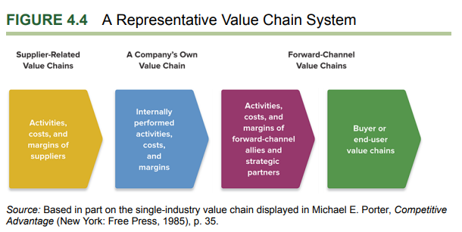
- Improving Supplier Related Value Chain Activities
  - Increase bargaining power to supplier: push for lower prices, push for increased service
  - Collaborating with suppliers to identify mutual cost saving opportunities such as JIT
  - Improve SRM: integrate suppliers into the design process, productive audits
- Improving Internally Performed Value Chain Activities
  - Implement best practices throughout the company
  - Redesign products to eliminate high cost component
  - Increase manufacturing efficiency
  - Outsource high cost activity such as manufacturing to lower cost vendors or contractors
  - Adopt new technologies that spur innovation
  - Design Thinking: reallocate resources to activities that address buyers’ most important purchase criteria
- Improving Value Chain Activities of Distribution Partners
  - Increase bargaining power to distributors: push for them to reduce price/markups
  - Collaborate to find win wins: chocolate supplier ships products in liquid form in tanks, reducing cost associated with molding and melting on both ends.
  - Integrating forward and removing them completely by selling direct to customers online or have their own retail store.
  - Cooperative advertising ‘buy toyota! Buy it at these dealerships near you!’
  - Train distributors on best practices

LO 4-5 Explain how a comprehensive evaluation of a company’s competitive situation can assist managers in making critical decisions about their next strategic moves

Comprehensive Evaluation = Resource Analysis(VRIO) + Value Chain Analysis + Benchmarking + Weighted competitive strength rating

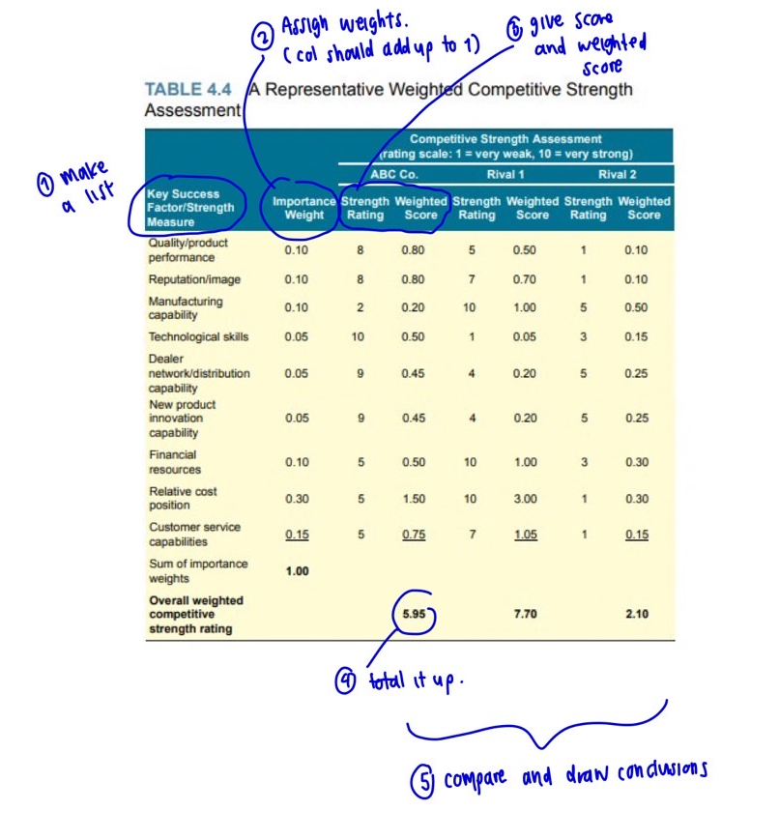
*for the chart without annotations: link
High-weighted competitive strength ratings signal a strong competitive position and possession of competitive advantage; low ratings signal a weak position and competitive disadvantage. If we want to attack a rival, we attack them in the area where they are weaker than us. If we want to defend, we should focus on areas where we are weaker than them.

Chapter 5 - The Five Generic Competitive Strategies - should be well matched to the company’s internal situation: leverages competitive and valuable resources and capabilities

Focused vs Broad target market
- When to be focused
  - Niche is big enough to be profitable and can have growth potential
  - Big players are not competing in the niche(avoid competition with the big boys)
    - It's too costly or difficult for the big boys to enter the niche
  - Many niche in the market exists, a lot of gaps
  - Few rivals exists - consider five forces
- When to be broad
  - Products if sold in the niche category can be easily substituted
  - Buyer’s preference changes quickly, so niche market can reduce in size easily

LO 5-1 Understand what distinguishes each of the five generic strategies and explain why some of these strategies work better in certain kinds of competitive conditions than in others.
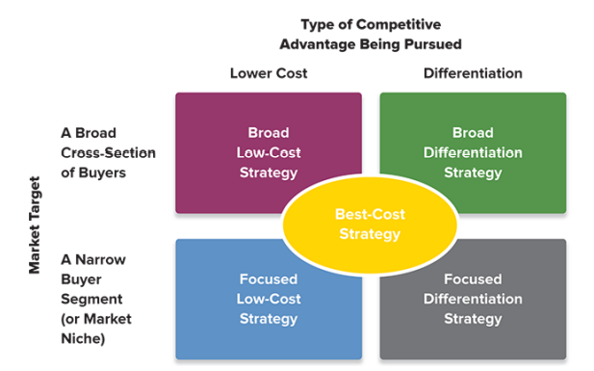

- A broad, low-cost strategy—striving to achieve broad lower overall costs than rivals on comparable products that attract a broad spectrum of buyers, usually by underpricing rivals.
- A broad differentiation strategy—seeking to differentiate the company’s product offering from rivals’ with attributes that will appeal to a broad spectrum of buyers.
- A focused low-cost strategy—concentrating on the needs and requirements of a narrow buyer segment (or market niche) and striving to meet these needs at lower costs than rivals (thereby being able to serve niche members at a lower price).
- A focused differentiation strategy—concentrating on a narrow buyer segment (or market niche) and offering niche members customized attributes that meet their tastes and requirements better than rivals’ products
- A best-cost strategy—striving to incorporate upscale product attributes at a lower cost than rivals. Being the “best-cost” producer of an upscale, multi featured product allows a company to give customers more value for their money by underpricing rivals whose products have similar upscale, multi featured attributes. This competitive approach is a hybrid strategy that blends elements of the previous four options in a unique and often effective way. It may be focused or broad in its appeal.

LO 5-2 Recognize the major avenues for achieving a competitive advantage based on lower costs.

Success in achieving a low-cost edge over rivals comes from out-managing rivals in finding ways to perform value chain activities faster, more accurately, and more cost effectively.

- strategic objective is meaningfully lower costs than rivals—not necessarily the absolutely lowest possible cost.
  - A cost driver is a factor that has a strong influence on a company’s costs.
- Two options to translate low cost advantage into superior profit
  - Lower its price to become more attractive to price sensitive buyers(may lead to price wars, but can also help to increase market share)
  - Maintain the same price and enjoy greater margins(market share stays the same)
- Two ways of reducing cost
  - Cost-Efficient Management of Value Chain Activities - Perform internal value chain activities and/or value chain system activities more cost-effectively than rivals.
    - See LO 1-3 for list of cost drivers
  - Revamping of the Value Chain System to Lower Costs(bypass some cost-producing activities)
    - Sell direct to customers, cut out the middleman
    - Streamline operations, eliminate unnecessary work steps(push it onto the supplier), instead of making your own noodles, buy the noodles
    - Reduce handling and shipping costs by forcing suppliers to move closer to you(JIT delivery)
- When to use: when customers are sensitive to price.
  - To survive price wars
  - Product can’t be differentiated or is basically the same in the industry, everyone's the same, so have to use price
  - Switching cost is low
- Things to be careful of
  - More units sold, more market share ≠ more profits, have to make sure that enough units are sold to make a profit
  - Cost reduction if not innovative enough can be easily copied by competitors
  - Too focused on cost reduction that it affects quality(feature-poor), fails to innovate

LO 5-3 Identify the major avenues to a competitive advantage based on differentiating a company’s product or service offering from the offerings of rivals.

Success = to be able to sell at a high enough price to cover the added costs of achieving differentiation.

- Strategic Objective: to offer unique product attributes a wide range of buyers find appealing and worth paying more for.
  - Justify premium price
  - Increase units sold
  - Gain buyer loyalty
- Two ways to differentiate
  - Innovate to offer better VP
    - Offer features that lowers buyer’s overall costs: sell cut to size component to help customers lower waste, add JIT service, better energy saving features, more durability etc
    - Incorporate tangible features such as new specifications, functions, styles.
    - Incorporate intangible features such as a more hiso brand image, want to look like a bougie bangkok girl? Buy this you need it to complete the look
  - Improve Value Chain to enhance differentiation
    - See LO 1-3 for list of value driver
- When to use
  - When buyer’s needs are diverse, many ways to offer value
  - Few rivals are differentiating(gaps can be identified in the strategic group map)
  - Technology is rapidly evolving, new opportunities to innovate exists, so have to keep up
- Things to be careful of
  - Make sure the differentiating feature actually has value, no one wants a curry and chocolate flavored cupcake just because it's different
  - Make sure customers understand why the differentiation is of value, sometimes customers don’t understand!
  - Overspending on differentiation can eat up your margins
  - Don’t just copy rivals
  - Over-differentiating to the point that it's too เวอร์ and no one wants it
  - Pricing - make sure its reasonable

LO 5-4 Explain the attributes of a best-cost strategy—a hybrid of low-cost and differentiation strategies.

- Ability to produce upscale features at a lower cost than other high-end producers.
- Ability to profitably offer the buyer more value for the money.
- Positions itself right in the middle, the ‘just right’ position, not too expensive, not too cheap, good quality
- Risk of being stuck in the middle, competition with all players in the market

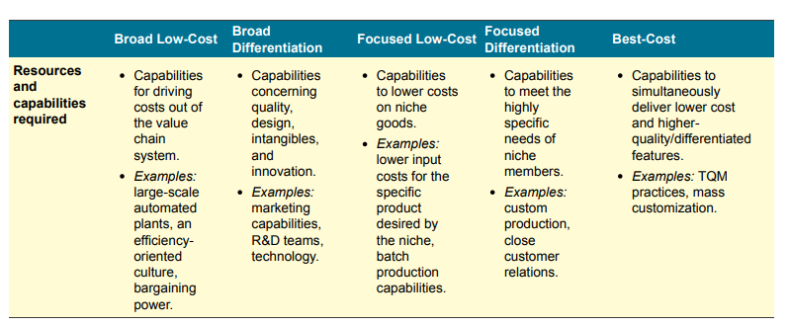
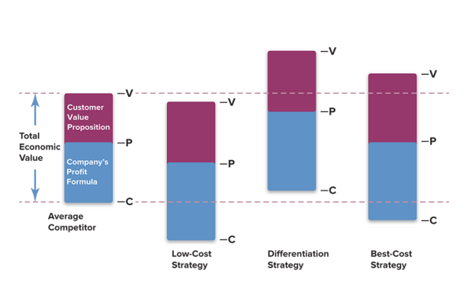

Chapter 6 - Strengthening a Company’s Competitive Position: Strategic Moves, Timing, and Scope of Operations

Once you decide on your basic strategy, you must decide what strategic action to take!
LO 6-1 Understand whether, how, and when to deploy offensive or defensive strategic moves.

SELECTING OFFENSIVE
- Strategic offensives should exploit the power of a company’s strongest competitive assets
  - Cost advantage: Offer good or better product at lower price
  - Superior RD: be first to market with new tech products, be more innovative than rivals
  - Super Creative; disruptive innovation to create new markets. BLUE OCEAN YEAHHH
    - blue-ocean strategy offers growth in revenues and profits by discovering or inventing new industry segments that create altogether new demand.
  - Sneaky: improve on rival’s good ideas,
  - Sneaky: guerrilla offensive hit and run tactics, catch them by surprise: surprise sales, surprise marketing spree
  - High agility: secure an industry’s limited resources or capture rare opportunity
    - Partnering up first with best distributors in a region
    - Get the best location to open up new store
    - Marry the best supplier(long term contracts, acquisition, exclusive partnerships)
    - Acquire assets of distressed rivals at bargain price
- Who to attack?
  - Market leaders that are vulnerable (when buyers are unhappy with the market leader)
  - Those that are weak where we are strong
  - Those that are about to go out of business- nail in the coffin
  - Small firms with limited capabilities of fighting back
SELECTIVE DEFENSIVE - may not enhance competitive advantage, but help to fortify current position
- Two main ways
  - Blocking
  - Signal that you will retaliate and be ready to commit to it publically

LO 6-2 Identify when being a first mover, a fast follower, or a late mover is most advantageous.
Because of first mover advantages and disadvantages, competitive advantage can spring from when a move is made.

- First mover advantage
  - Builds reputation as being the ‘original’ one, create strong brand loyalty
  - May increase buyer’s switching costs, my first phone is an iphone, im used to it, i don’t understand android.
  - IP protection - first to file for patent, trademark, copyright, etc limits copy cat, increase barrier to entry
  - When rivals introduce their product, our price is already much lower as our costs are lower due to head start(there’s a learning curve, EoS benefits, etc)
  - You define the industry - set the standard that the product has to be ‘like this’
  - Build strong network effect: everyone is using facebook, I don’t want to use snapchat, no one is on there its too new.
- Second mover advantage
  - Learn from first mover(lower RD cost, lower risks)
- Important things to consider
  - Does market takeoff depend on the development of complementary products or services that currently are not available?
  - Is new infrastructure required before buyer demand can surge?
  - Will buyers need to learn new skills or adopt new behaviors?
  - Will buyers encounter high switching costs in moving to the newly introduced product or service?
  - Are there influential competitors in a position to delay or derail the efforts of a first mover?

LO 6-3 Explain the strategic benefits and risks of expanding a company’s horizontal scope through mergers and acquisitions.
The scope of the firm refers to the range of activities that the firm performs internally, the breadth of its product and service offerings, the extent of its geographic market presence, and its mix of businesses.

- Horizontal scope is the range of product and service segments that a firm serves within its focal market.
- Vertical scope is the extent to which a firm’s internal activities encompass the range of activities that make up an industry’s entire value chain system, from raw material production to final sales and service activities.
- Mergers and Acquisitions (mergers is combining, acquisition is absorbing)
  - Objectives
    - Create better cost efficiency
    - Expand geographic coverage
    - Expand product portfolio
    - Gain access to tech, resource, capabilities
    - Be more agile
  - Why they fail - expectation vs reality
    - Not enough homework was done
    - Culture clash - low motivation/morale
    - Can’t retain all the staff(loss of capabilities)
    - Bad management

LO 6-4 Explain the advantages and disadvantages of extending the company’s scope of operations via vertical integration.

A vertically integrated firm is one that performs value chain activities along more than one stage of an industry’s value chain system.
- (+) Enhance competitiveness (reduce cost, improve quality, offer better VP)
- (-) Uses a lot of money, financial risk if it fails, increases business risk
- (-) reduced agility, instead of buying the newest hottest stuff, you’re stuck with homemade things
- (-) limits EoS, you’re producing things just for yourself, not in a big quantity, capacity matching problems
- (-) a lot of headache, a lot of work
- Things to consider
  - Can it enhance the performance of strategy-critical activities in ways that lower cost, build expertise, protect proprietary know-how, or increase differentiation;
  - What impact vertical integration will have on investment costs, flexibility, and response times;
  - What administrative costs will be incurred by coordinating operations across more vertical chain activities; and
  - How difficult it will be for the company to acquire the set of skills and capabilities needed to operate in another stage of the vertical chain

LO 6-5 Recognize the conditions that favor farming out certain value chain activities to outside parties.
Outsourcing involves contracting out certain value chain activities that are normally performed in-house to outside vendors.
- When to use
  - Other people can do it at a lower cost, better quality
  - Not important in the value chain, allow company to concentrate on what it does well
  - Improves agility (reduce risk of changing market conditions)
- Things to consider
  - Vendors can copy your skill and expertise
  - Level of control - can you control them?

LO 6-6 Understand how to capture the benefits and minimize the drawbacks of strategic alliances and partnerships.
A strategic alliance is a formal agreement between two or more separate companies in which they agree to work cooperatively toward some common objective. A joint venture is a partnership involving the establishment of an independent corporate entity that the partners own and control jointly, sharing in its revenues and expenses.
- Companies that have formed a host of alliances need to manage their alliances like a portfolio.
- Good alliances were formed smartly, focusing on a value chain synergy, mutual benefits, enhances capabilities
  - Pick good partner: all parties are not direct competitors(suppliers/distributors), trustworthy
  - Be aware of cultural differences
  - Recognize that it must be win-win to be sustainable, otherwise feelings can be hurt
  - Ensure accountability, define who does what
  - Structuring the decision making process well, who is the decision maker?
  - Be agile, adjust as you see fit

Pros
- It facilitates achievement of an important business objective (like lowering costs or delivering more value to customers in the form of better quality, added features, and greater durability).
  - Lowering cost through resource pooling, risk sharing, good to do when uncertainties are high
- It helps build, strengthen, or sustain a core competence or competitive advantage.
  - Become more agile, strength in number
- It helps remedy an important resource deficiency or competitive weakness.
- It helps defend against a competitive threat, or mitigates a significant risk to a company’s business.
- It increases bargaining power over suppliers or buyers.
- It helps open up important new market opportunities
- It speeds the development of new technologies and/or product innovations.

Things to consider
- Ownership ties are more permanent than partnership ties
- Create a system to manage alliances
- Build relationship and trust
- Be careful, have safeguards in place in case of backstabbing
- Always learn from each other, play nice

Chapter 7 - Strategies For Competing in International Markets (Lecture 7)

Horizontal Integration: range of product and service segment that a firm serves within a market.
Home Country Advantage

LO 7-1 Identify the primary reasons companies choose to compete in international markets.

- To gain access to new customers
- Achieve lower costs through EoS, experience, increased purchasing power
- To Gain access to low-cost inputs of production
- To further exploit core competencies - mcdonalds pursued the international market because they know their low cost fast food products are super attractive to many customers not limited to just the US.
- To gain access to resources and capabilities located in foreign markets
  - Form partnerships/alliances and gain access to capabilities that complement their own
  - Utilize local distribution networks
  - Acquire specialized technical knowledge
- To follow their main customer’s expansion abroad. Ex. Toyota’s car parts supplier follows them to whichever country that they go to because they're buddies.

LO 7-2 Understand how and why differing market conditions across countries influence a company’s strategy choices in international markets.

Diff country =
- Diff home country advantage
- Diff location based advantages - wage rates, worker productivity, energy costs
- Diff political and economic conditions - local gov are either super eager to attract foreign investments, or shut them off completely. Tax incentives, low-cost loans, land ownership.
  - Political risks stem from instability or weakness in national governments and hostility to foreign business.
  - Economic risks stem from instability in a country’s monetary system, economic and regulatory policies, and the lack of property rights protections.
- Risks due to forex
- Diff Buyer’s preferences


Demand Conditions
- Emerging vs mature markets
- Demographics difference

Firm strategy, structure, rivalry
- Asian companies are more likely to partner up and form alliances with their rivals
- Western companies are more individualistic

The Diamond Framework can be used to
- Predict from which countries foreign entrants are most likely to come
- Decide which foreign markets to enter first
- Choose the best country location for different value chain activities

LO 7-3 Identify the differences among the five primary modes of entry into foreign markets
- Maintain a home-country production base and export goods to foreign markets.
  - (+) low capital requirement, EoS, no distribution risk, no direct investment risk
  - (-) Transportation and shipping costs, exchange rate risks, tariffs and import duties, loss of channel control.
- License foreign firms to produce and distribute the company’s products abroad.
- Employ a franchising strategy in foreign markets.
  - (+) low resource requirement, income from royalty and franchising fee, rapid expansion into many markets
  - (-) loss of know-how
- Establish a subsidiary in a foreign market via acquisition or internal development
  - A greenfield venture (or internal startup) is a subsidiary business that is established by setting up the entire operation from the ground up
  - Acquisition is faster, less risky, more cost efficient as it bypasses entry barriers
- Rely on strategic alliances or joint ventures with foreign companies
  - Cross-border alliances enable a growth-minded company to widen its geographic coverage and strengthen its competitiveness in foreign markets; at the same time, they offer flexibility and allow a company to retain some degree of autonomy and operating control.
  - Risks
    - Expectations vs reality, conflicting objectives, cultural differences, etc
    - Alliance partners if given full access to proprietary technological expertise or other valuable capabilities may backstab u.
    - Dependency, 50-50 JV results in both side not doing 100%

LO 7-4 Identify the three main strategic approaches for competing internationally.

An international strategy is a strategy for competing in two or more countries simultaneously

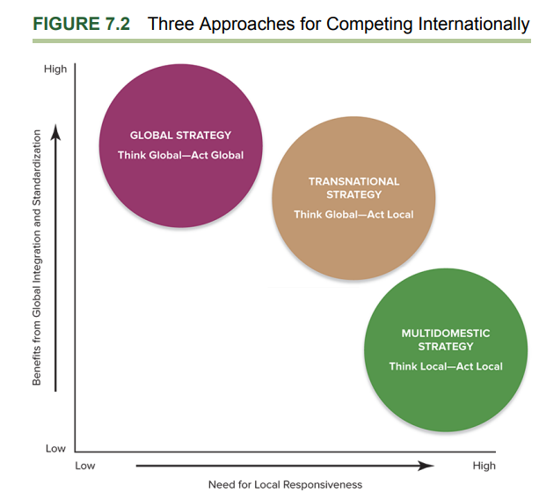

A global strategy is one in which a company employs the same basic competitive approach in all countries where it operates, sells standardized products globally, strives to build global brands, and coordinates its actions worldwide with strong headquarters control. It represents a think-global, act global approach.
- (-) Cannot address local needs as directly as a localized strategy
- (-) Less responsive to change in local market conditions, ‘my way or no way’
- (-) may raise transportation costs and higher tariffs if products are imported in for sale domestically
- (-) higher coordination costs due to the complex task of a global value chain management
- Ex. Apple, Coke

A transnational strategy is a thinkglobal, act-local approach that incorporates elements of both multidomestic and global strategies. ‘Glocalization’
- Mass Customization technique - McDonald has their core menu that is the same in every country, but has a local menu as well. Thailand has jok and kaprao.
- (-) They are the most difficult of all international strategies to implement due to the added complexity of varying the elements of the strategy to situational conditions.
- (-) They place large demands on the organization due to the need to pursue conflicting objectives simultaneously.
- (-) Implementing the strategy is likely to be a costly and time-consuming enterprise, with an uncertain outcome.
- Ex. KFC, EA Games, Minor Hotels: expanded its hospitality operations into a broad diversity of countries(safari in africa, hotel in thailand, maldives, etc)

A multidomestic strategy is one in which a company varies its product offering and competitive approach from country to country in an effort to be responsive to differing buyer preferences and market conditions. It is a think-local, actlocal type of international strategy, facilitated by decision making decentralized to the local level.
- (-)limits total transfer of core competencies and strategic resources.
- (-) Variety = less EoS, raises production and distribution costs.
- (-)worldwide competitive advantage is not strong. Can only yield local competitive advantage.

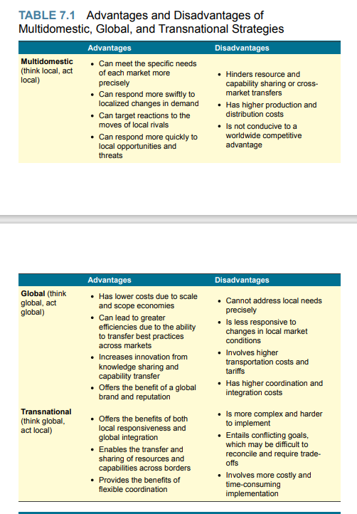

LO 7-5 Explain how companies are able to use international operations to improve overall competitiveness.

- Using location: Locate value chains activities in whichever nation prove most advantageous(lowest cost, highest quality)
  - Cost of manufacturing: manufacturer in china, assembled in the USA
  - Economy of scale
  - Learning and experience opportunities
  - Access to resources
  - Financial regulation: HQ in HK is attractive due to tax benefits
- Sharing and transferring resources and capabilities across borders
  - Resources such as brand image and reputation. Channel is famous, everyone in every country usually buys it
  - Capabilities such as efficient production systems. Toyota transfers best practices to local workforce in their Thai subsidiaries to yield production efficiency and effectiveness.
- Cross border coordination
  - Responsive to changing political and economical conditions
  - Shift production from one plant to another in a different country when faced with component shortage, etd
  - Cross border strategic moves
    - Offensive moves
      - Multiple source of profit = higher financial strength
      - Cross-market subsidization— supporting competitive offensives in one market with resources and profits diverted from operations in another market— can be a powerful competitive weapon. Celine has the money to hire Lisa, Naraya doesn’t
      - Dumping - selling products or services well below the price of domestic sellers at well below its full cost per unit to gain market share. Big companies can do this because they can afford lost leaders.
    - Defensive Moves
      - The threat of crossborder counterattacks may be enough to encourage mutual restraint among international rivals.
      - Attack where they are weak and we are strong
  - Multimarket competition refers to a situation where rivals compete against one another in many of the same markets

LO 7-6 Identify the unique characteristics of competing in developing-country markets

Offensive Strategy options for competing in developing country markets
- Low price strategy - they don't have a lot of buying power.
- Modify business model to accommodate unique local circumstances of developing countries
- Change the local market to better match the way the company does business in the home country.
  - Sanitary pads were not a thing in India, usually when girls get period they stay home. So pad producing company has to do marketing to educate india on why thats fucked up.
- When it's impractical or uneconomical to modify a business model to accommodate local circumstances, give up.
  - Profitability in developing markets rarely comes quickly or easily—new entrants have to adapt their business models to local conditions, which may not always be possible.

Defensive Strategy options if you’re a seller in the developing country market
- Leverage home country advantages
  - Well established networks
  - Understanding of local customer needs
  - Understanding of local workforce
- Acquisition and rapid growth strategies to better defend against expansion minded farangs
- Transfer company expertise to cross border markets and initiate actions to contend on an international level.
Yiji: thai people more reactive than they are proactive(thai people are lazier than chinese people)

Chapter 8 - Corporate Strategy - Diversification and the Multibusiness Company

Steps involved in diversification strategy
- Pick new industries to enter and deciding on how to enter
- Pursue opportunities to leverage cross business value chain relationships, strategic fit, strengthen competitive advantage
- Initiate actions to boost combined performance of the newly diversified business

LO 8-1 Explain when and how business diversification can enhance shareholder value.

Initiative must pass the Tests of Corporate Advantage to ensure that shareholder value can be enhanced.
- Attractiveness test - is the industry capable of making good profit?
- Cost of entry test - is the cost of barrier low enough that we can enter at not the cost of extensive time and financial resources?
- Better off test - how much synergy will be gained by diversifying into the industry? (1+1 = 100), have to benefit both sides if acquisition or JV

How to diversify?
- Internal Development - has to be cheap enough to do
  - Corporate venturing (new venture development, corporate entrepreneurship, intrapreneurship) - developing new businesses as an outgrowth of a company’s established business operations
- Joint Venture - can be risky and hard to manage, however if relationship is good it can be good
  - When diversification is too hard to do alone(complex, uneconomical, risky etc)
  - Requires a pooling of resources and capabilities
- Acquiring a company - need to have good synergy
  - An acquisition premium, or control premium, is the amount by which the price offered exceeds the pre acquisition market value or stock price of the target company

How to Enter the Market? Things to consider
- Critical resources and capabilities are required: have to buy or do JV to gain it, if can do it yourself, you can do it yourself.
- Entry Barrier exists: Have to buy or do JV if the barrier is too high. If low, can do it internally, no need to buy.
- Is time of the essence? If you need to enter quickly to capture opportunity, have to choose to buy
- Comparative cost? How can we enter the market the most cost-effective way? Consider the total landed cost.
  - Transaction costs are the costs of completing a business agreement or deal, a hidden cost. The cost associated with acquisition/JV. Ex. the costs of searching for an attractive target, the costs of evaluating its worth, bargaining costs, and the costs of completing the transaction.
  - Goodwill: premium you pay on top of the valuation price when acquiring a company.

Related vs Unrelated
- Related businesses possess competitively valuable cross business value chain and resource commonalities
- Unrelated businesses have dissimilar value chains and resource requirements, with no competitively important cross business commonalities at the value chain level

LO 8-2 Describe how related diversification strategies can produce cross-business strategic fit capable of delivering competitive advantage.

Diversifying into related businesses where competitively valuable strategic-fit benefits can be captured puts a company’s businesses in position to perform better financially as part of the company than they could have performed as independent enterprises, thus providing a clear avenue for increasing shareholder value and satisfying the better-off test.
Related diversification strategy involves building the company around businesses where there is good strategic fit across corresponding key value chain activities. Strategic fit exists whenever one or more activities constituting the value chains of different businesses are sufficiently similar to present opportunities for cross-business sharing or transferring of the resources and capabilities that enable these activities.
- Not product relatedness, but relatedness of key value chain activities and specialized resources and capabilities.
- Cross-Business Strategic Fit enables Economy of Scope - cost reductions that flow from operating in multiple businesses.
  - Potential cost savings from combining customer service activities, distribution related activities, sales and marketing activities, manufacturing related activities, supply chain activities, RD activities, etc
- Transfer of specialized competencies and/or valuable strategic assets from one value chain to another.
  - Sharing costs between businesses by combining related value chain activities into a single operation. Ex. procurement activities, shipping and distribution activities
  - Exploit common use of a well-known brand name. Ex. Apple’s brand name is valuable, when they started selling phones, people still buy.
  - Cross-business collaboration and knowledge sharing to create new competitively valuable resources and capabilities (1+1=100)
- Specialized resources and capabilities have very specific applications and their use is limited to a restricted range of industry and business types, in contrast to general resources and capabilities.
- The most competitively valuable opportunities for resource sharing or transfer always come from leveraging specialized resources and capabilities.

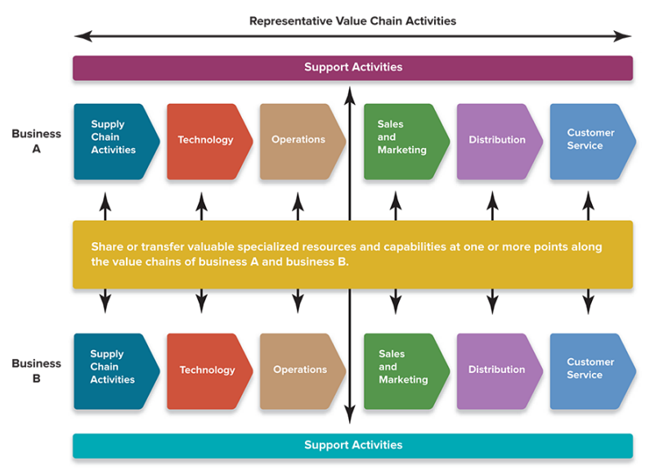

LO 8-3 Identify the merits and risks of unrelated diversification strategies.

Conglomerates pursue unrelated diversification as their business interests range broadly across diverse industries. They are willing to diversify into any business in any industry as long as it:
- Meet corporate targets for profitability and return on investment
- Is in an industry with attractive growth potential (Pestel and Five force analysis concludes that it is attractive)
- Can contribute significantly to the parent firm’s bottom line.
- Can pass the better off test

Building Shareholder Value via Unrelated Diversification
- Corporate Parent - Success can be maximized if parent company holds strong parenting capabilities to propel the business forward(make the combination better off)
  - Transfer resource and capabilities of any type
    - Business that is ‘done the same way’
    - Sell to the same people
    - Combining normal activities to reduce company wide overhead costs(reduce duplicate activities through centralizing activities)
    - top management expertise, disciplined control, financial resources, and other types of general resources and capabilities such as long-term planning systems, business development skills, management development page 241 processes, and incentive systems.
- Astute corporate parenting by management - offering high level oversight and guidance
- Cross building allocation of financial resources - creating an internal capital market, reallocation of surplus cash flow from one business to fund capital requirements of other businesses.
- Acquiring and restructuring undervalued companies - overhauling and streamlining the activities of a business— combining plants with excess capacity, selling off underutilized assets, reducing unnecessary expenses, and otherwise improving the productivity and profitability of a company.
- An umbrella brand is a corporate brand name that can be applied to a wide assortment of business types. As such, it is a type of general resource that can be leveraged in unrelated diversification.
- Three Key Activities to ensure success
  - Diversify into industries where the businesses can produce consistently good earnings and returns on investment (to satisfy the industry-attractiveness test).
  - Negotiate favorable acquisition prices (to satisfy the cost of entry test).
  - Do a superior job of corporate parenting via high-level managerial oversight and resource sharing, financial resource allocation and portfolio management, and/or the restructuring of underperforming businesses (to satisfy the better-off test).
    - A diversified company has a parenting advantage when it is more able than other companies to boost the combined performance of its individual businesses through high-level guidance, general oversight, and other corporate level contributions.

The drawbacks of unrelated diversification
- Demanding managerial requirements
- Limited Competitive Advantage Potential - consolidated performance of an unrelated group of businesses may not be greater than what the individual business units could achieve if they were independent

Bad reasons to pursue unrelated diversification
- Risk reduction - investing in companies is more risky than investing in stocks and bonds
- Growth -don’t just pursue growth for growth's sake. Make sure it is profitable growth.
  - Only profitable growth—the kind that comes from creating added value for shareholders—can justify a strategy of unrelated diversification.
- Stabilization - operating in unrelated markets helps to diversity risks? Wrong!
- Managerial motives - managers may gain high compensation from diversifying so they pursue it- however if shareholder value can not be maximized through diversification, they would be violating their fiduciary responsibilities(duty of managers to put interest of shareholders first)

Firms can also pursue diversification into both related and unrelated industries. Combination related–unrelated diversification strategies have particular appeal for companies with a mix of valuable competitive assets, covering the spectrum from general to specialized resources and capabilities.

LO 8-4 Use the analytic tools for evaluating a company’s diversification strategy.
- Evaluate Industry Attractiveness - give each an importance weight, then give attractiveness rating, to calculate the weighted score of each.
  - Market size and projected growth rate
  - Intensity of competition
  - Emerging opportunities and threats
  - Presence of cross-industry strategic fit
  - Resource requirements
  - Social, political, regulatory, and environmental factors
  - Industry profitability
  - 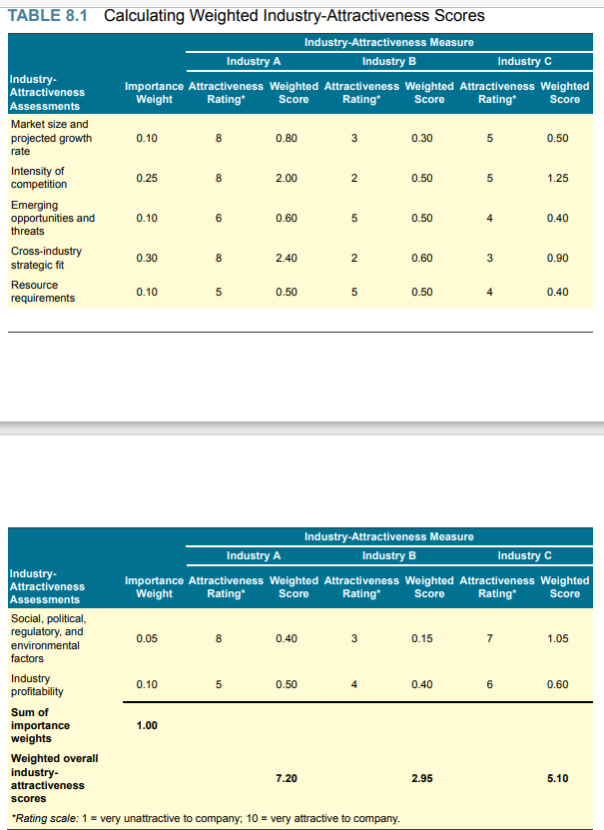

LO 8-5 Understand the four main corporate strategy options a diversified company can employ to improve company performance.

Strategic Diversification options
- Stay within the same industry
- Consider diversifying when
  - Growth opportunities are limited as market reaches maturity, sunset industry
  - Changing industry conditions - new tech, new substitute, shifting buyer preferences, increased competition
- How wide range should diversification be?
  - Related vs unrelated -
  - For a bit more revenue or for a lot more revenue?
- How to diversify?
  - Internal Effort - has to be cheap enough to do
  - Joint Venture - can be risky and hard to manage, however if relationship is good it can be good
  - Acquiring a company - need to have good synergy
- Poor rationales for unrelated diversification
  - Seeking a reduction of business investment risk
  - Pursuing rapid or continuous growth for its own sake
  - Seeking stabilization of earnings to avoid cyclical swings in business - have to be sure that there is a synergy and make it worthwhile to diversity, otherwise, just buy shares, don’t manage it yourself
  - Pursuing personal managerial motives
- Steps to evaluate the strategy of a diversified firm
  - Assess attractiveness of the industries the firm has diversified into, both individually and as a grou
  - Competitive strength of the firm’s business units
  - … more on slide
- How do we assess industry attractiveness? Key measures:
  - Market size and projected growth rate
  - Intensity of competition among market rivals
  - Emerging opportunities and threats
  - Presence of cross industry strategic fit
Resource requirements
Social, political, regulatory, environmental factors
Industry profitability

